**Lesson 11 Demo 4**

**Create a Container Instance**



Steps to be followed:

1. Going to the Azure portal

2. Clicking on Create a resource

3. Selecting Containers and click on Container Instances

4. Creating a Container Instance

**Step 1: Going to the Azure portal**

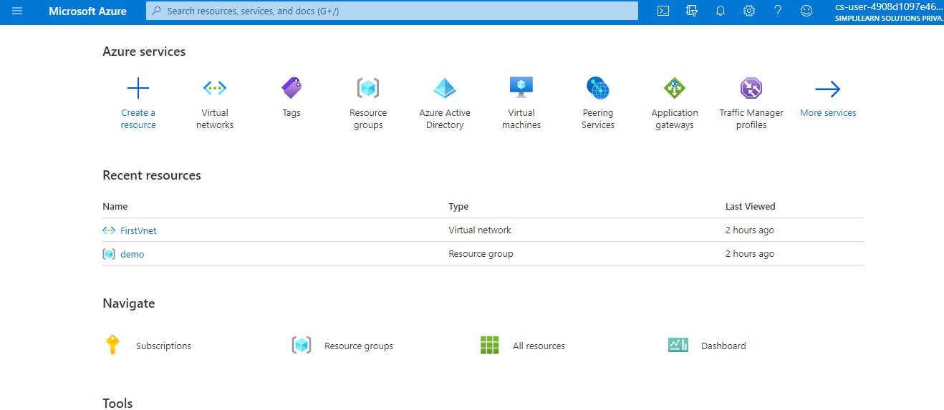

**Step 2: Creating a resource**

2.1Select **Create a resource**

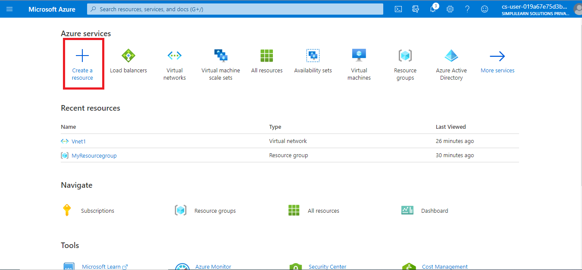

**Step 3: Selecting Containers**

3.1Select **Containers** and then **Container instances**

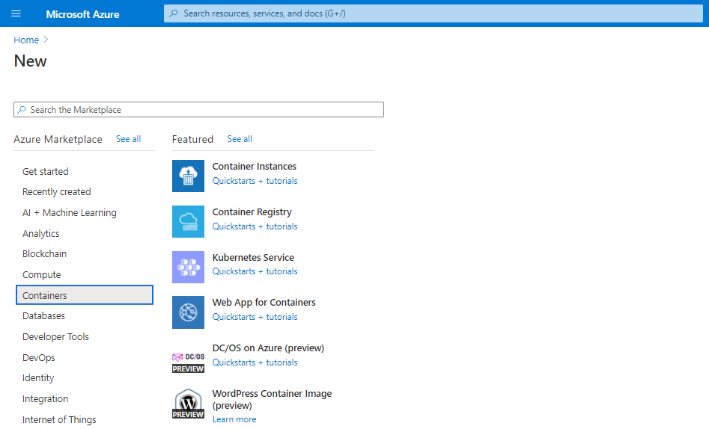

**Step 4: Creating a Container Instance**

4.1 On the Basics page, enter the following values

* Resource group
* Container name
* Container image text boxes

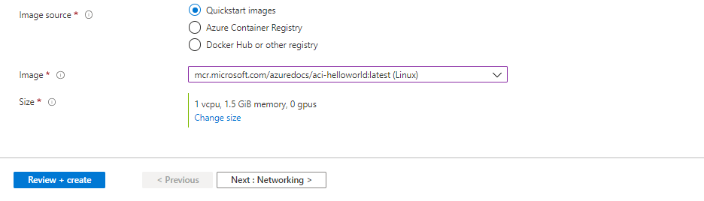

4.2 On the Networking page, specify a DNS name label for your container. The name must be unique within the Azure region where you create the container instance. Your container will be publicly reachable at <dns-name-label>.<region>.azurecontainer.io. If you receive a "DNS name label not available" error message, try a different DNS name label

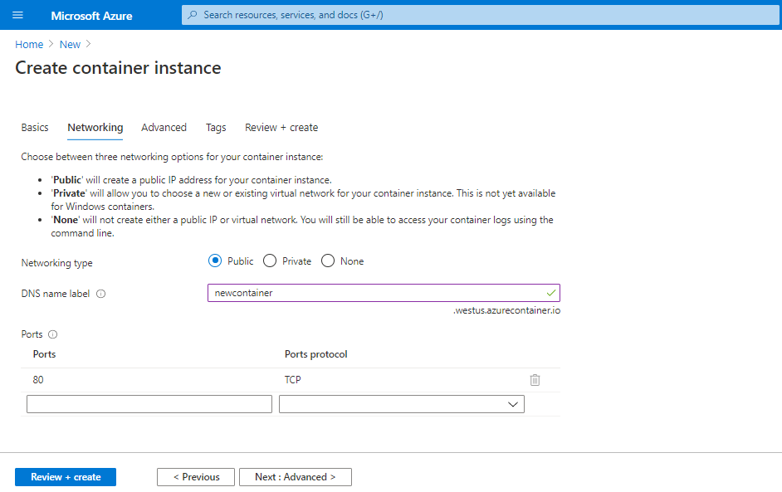

4.3 Leave the other settings as default and click on **Review + create**

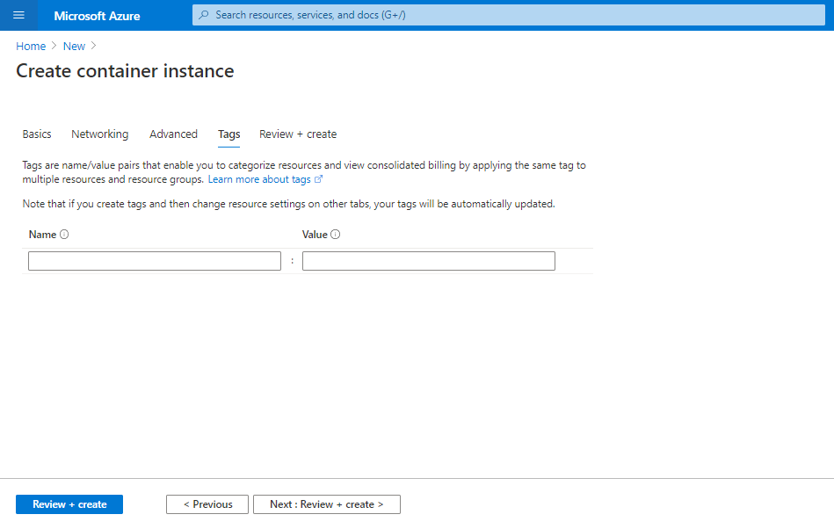

4.4 When the validation completes, a summary of the container's settings will be shown. Click on **Create** to submit your container deployment request

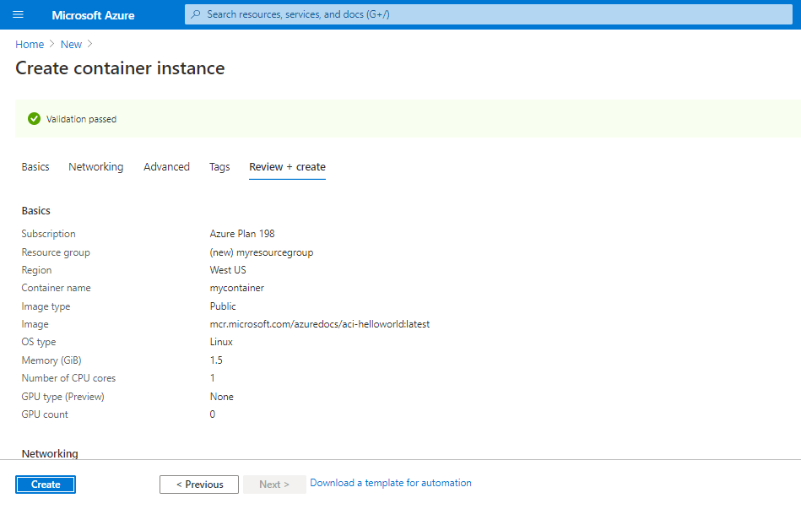

Your container instance will get deployed.

